September – November Sunday School curriculum

9:15 SERVICE: PREK- 2ND GRADE

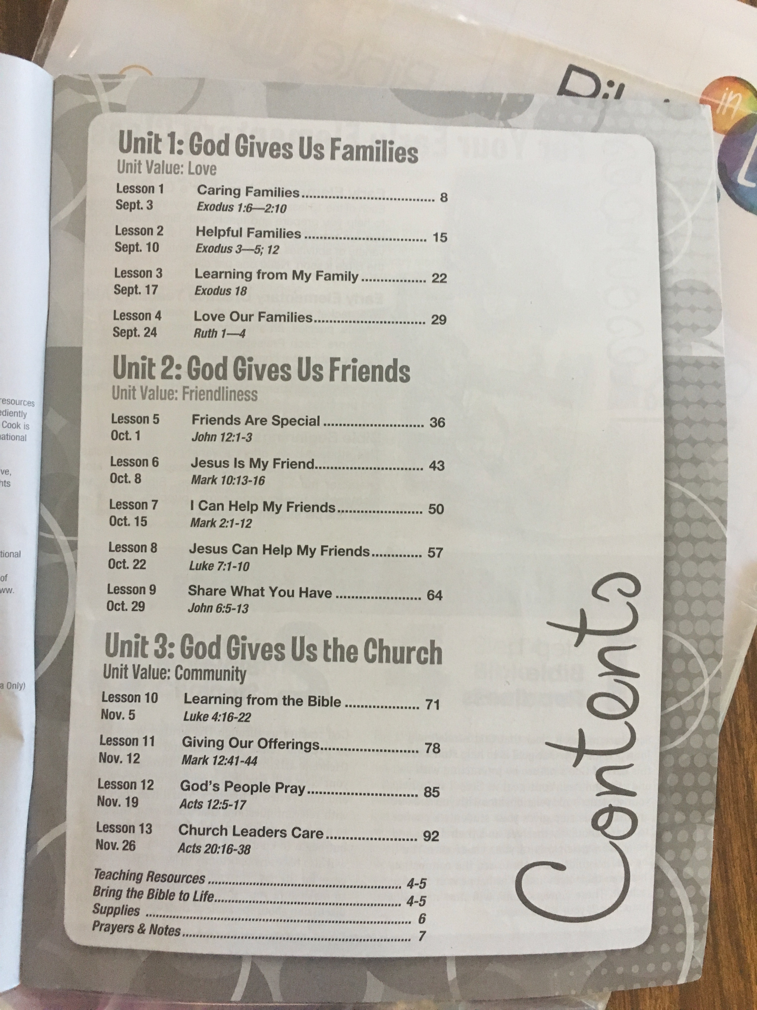

9:15 SERVICE: 3RD – 5TH GRADE
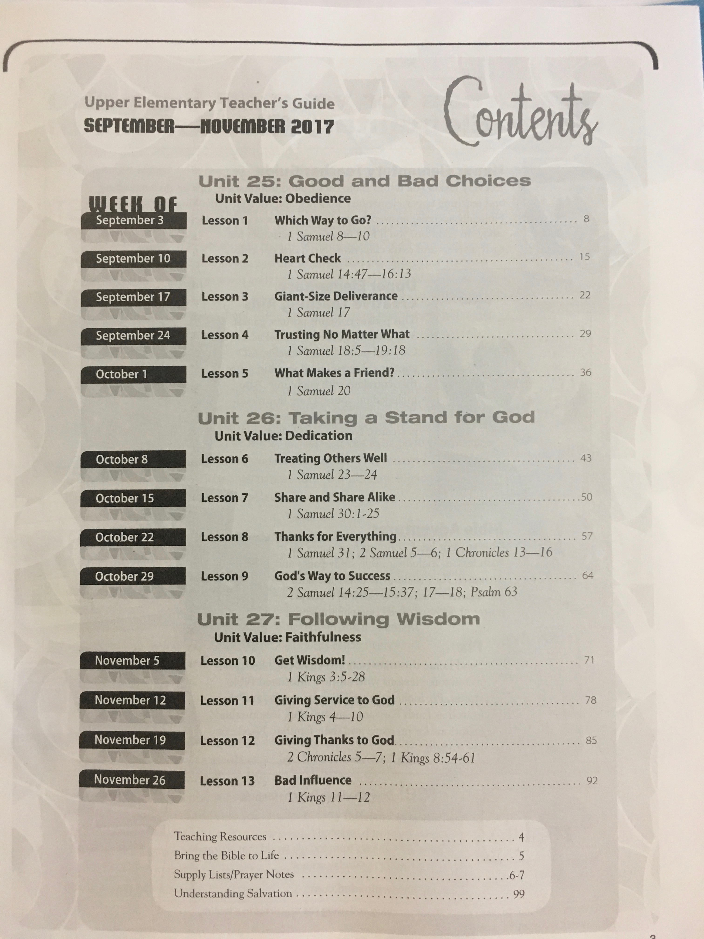

9:15 SERVICE: MIDDLE SCHOOL (6TH-8TH)
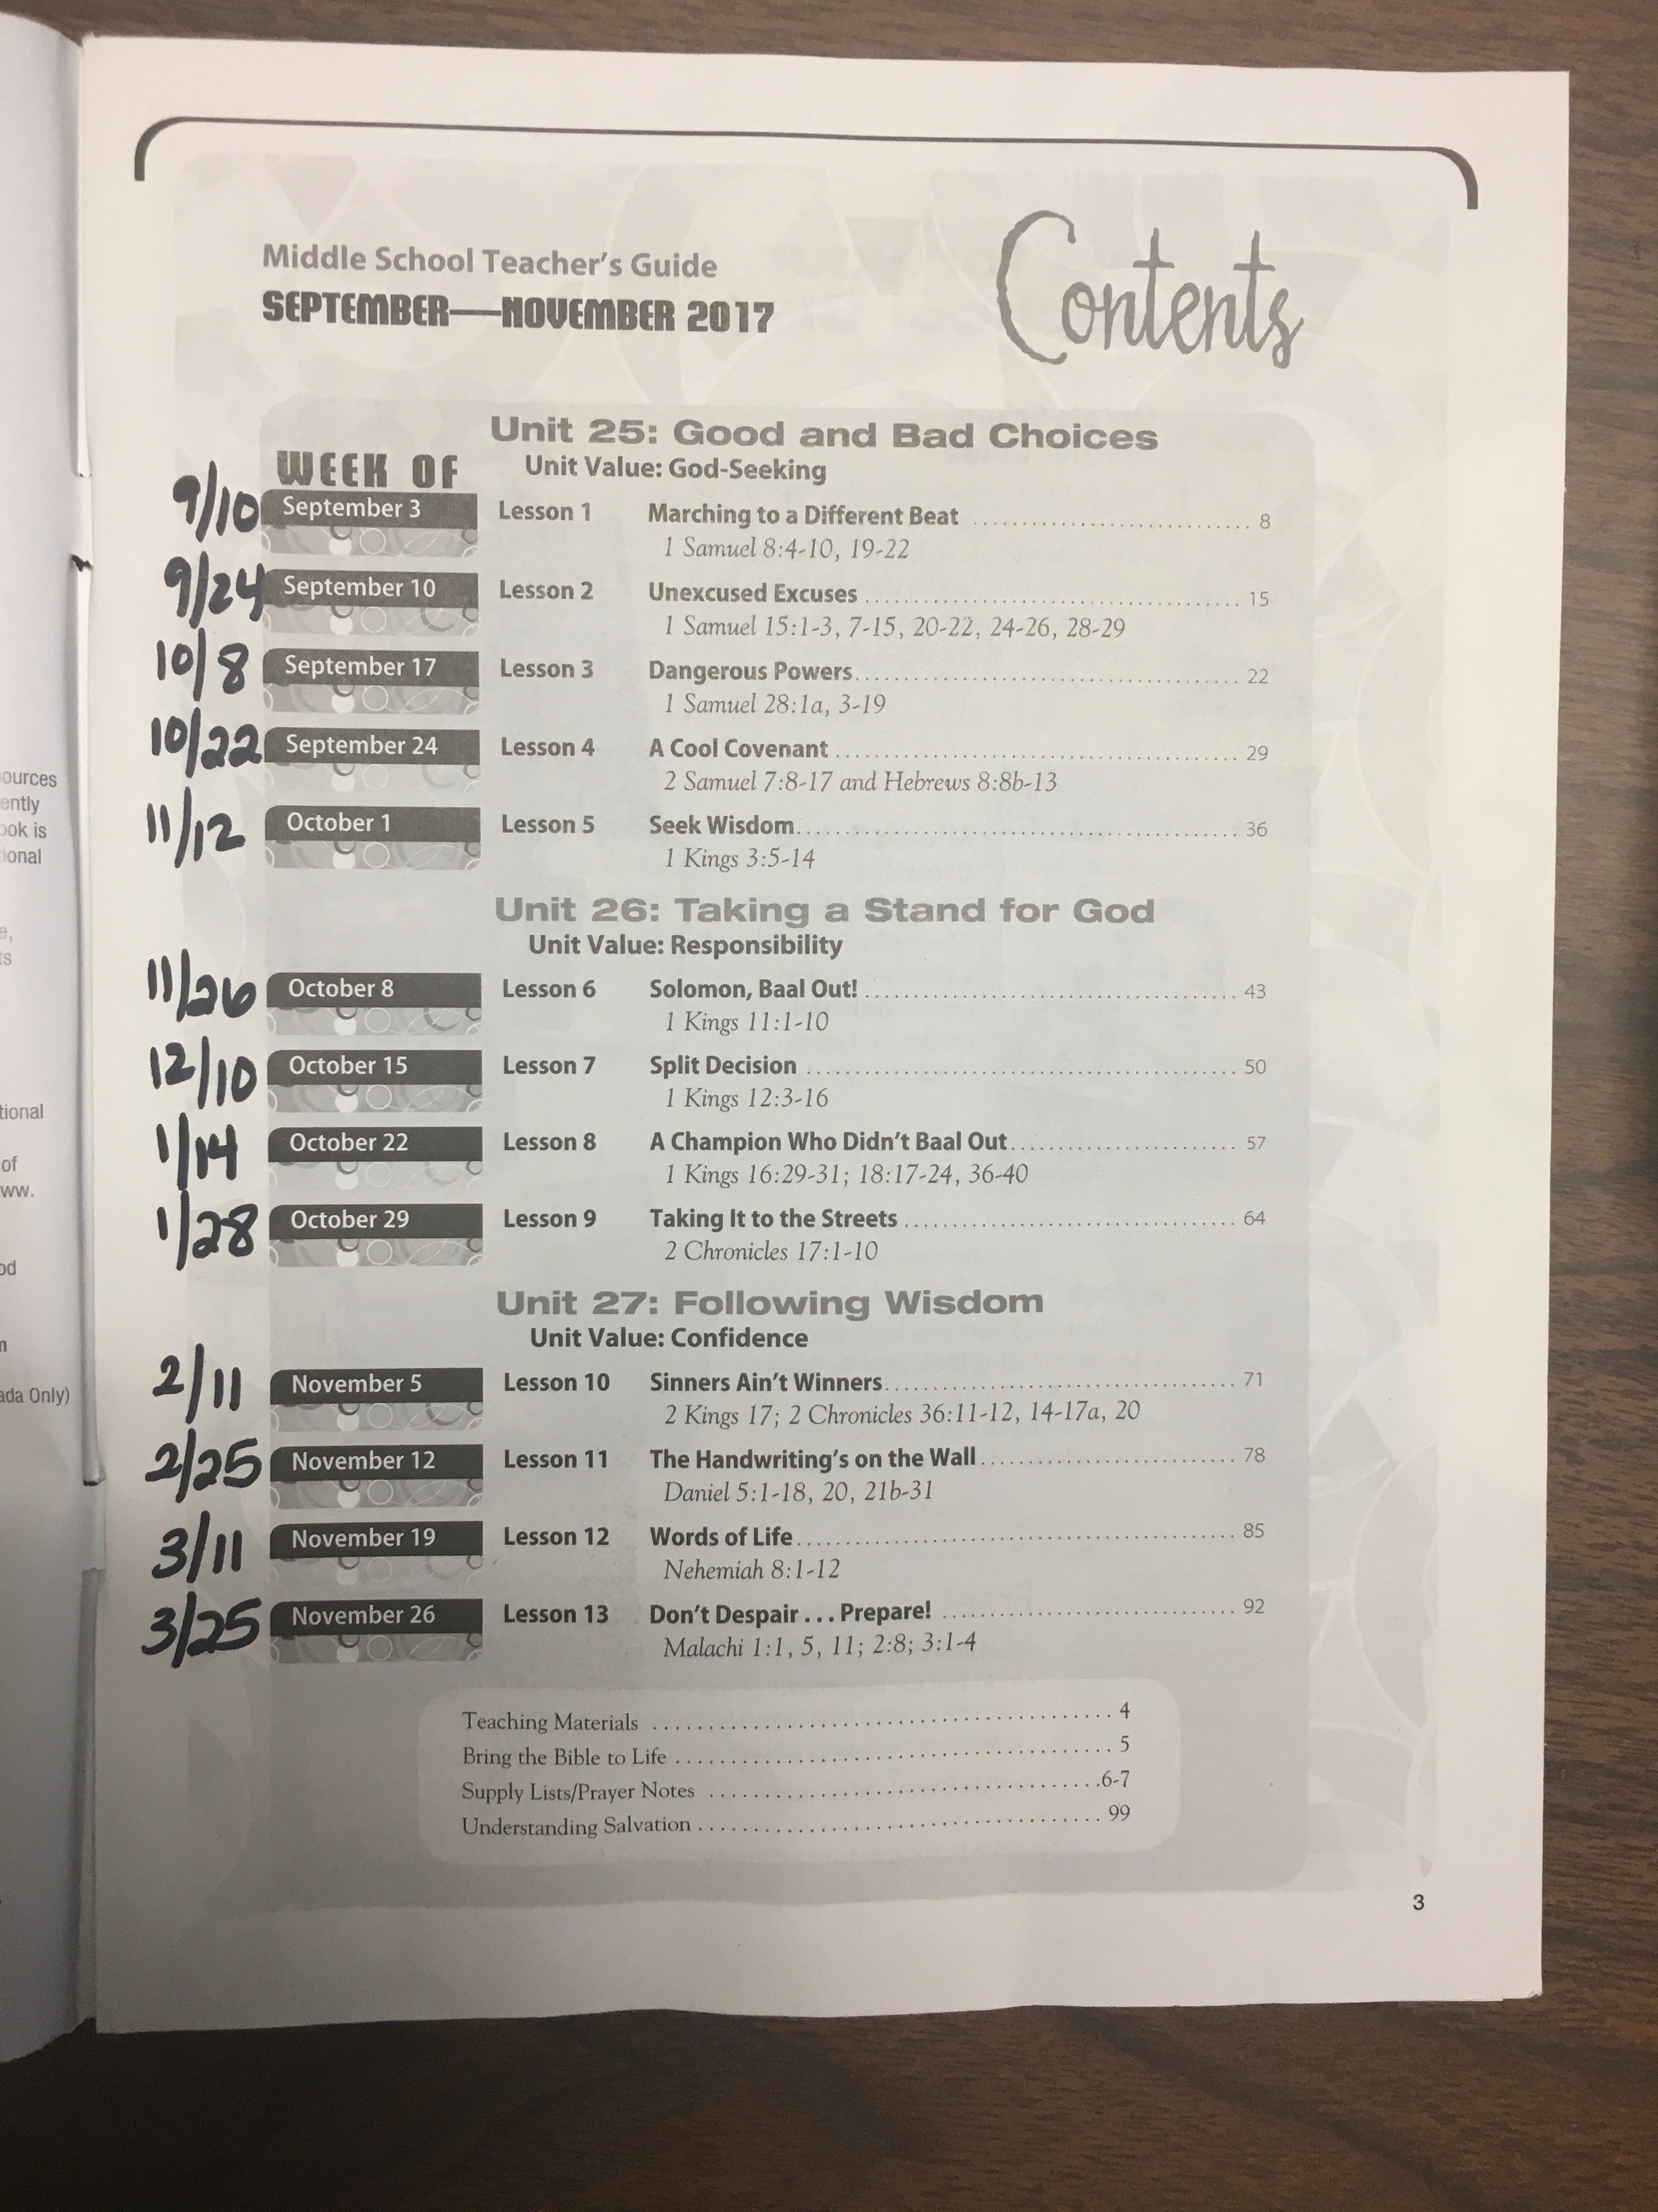

11:15 SERVICE: All graders, 5th and under
